

STEELE PROPERTIES MEDIA RELEASE

FOR IMMEDIATE RELEASE
Contact: Lynn Haner, Communications Manager, lhaner@steelellc.com, (direct) 720.215.3223 (mobile) 303.253.5968

MONROE GROUP PORTFOLIO NOW EXCEEDS 5,000 UNITS WITH STEELE PROPERTIES $ 33.7M ACQUISITION AND REHABILIATION OF RALEIGH MILLBANK APARTMENTS IN RALEIGH, NC

[Denver, CO, November 15, 2017] – Steele Properties announced the $33.7M acquisition and renovation of Project Based Section 8 property, Raleigh Millbank Apartments. The neighboring apartment complexes previously were two separate properties, Raleigh North Apartments and Milbank Court Apartments, and now will be known as Raleigh Millbank. This marks Steele’s fourth acquisition in North Carolina. Monroe Group, Ltd., Steele’s management partner, will oversee property management of Raleigh Milbank. With this acquisition, Monroe Group’s national portfolio now exceeds 5,000 units.

“We are pleased that we have been able to preserve more than 5,000 affordable housing units nationally with this latest acquisition. Through this important public and private partnership involving NCHFA, HUD, the City of Raleigh, NDC and R4 Capital, we are able to preserve much needed affordable housing at a time when our country is experiencing an affordable housing crisis.” said David Asarch, Partner, Steele Properties.

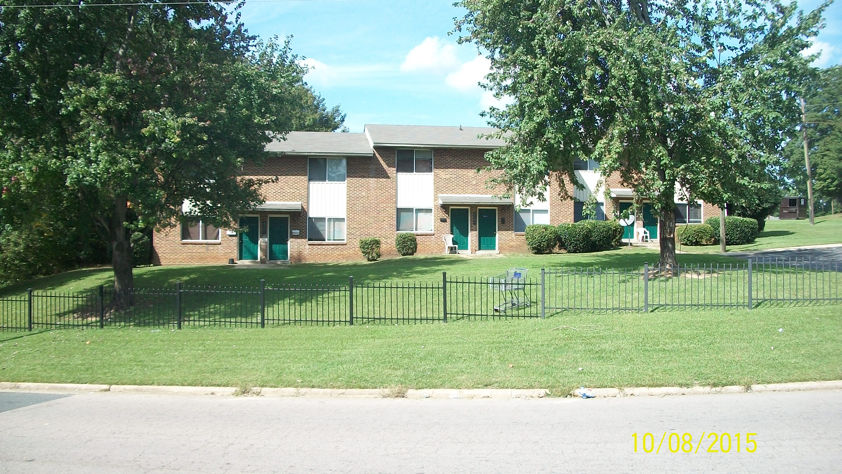
Raleigh Milbank will receive approximately $49,000 per unit in hard cost rehabilitation as part of Steele Properties’ acquisition. The scope of renovation encompasses both extensive exterior and interior work. Important building improvements include new roofs, windows, HVAC systems, plumbing and electrical upgrades as well extensive health, safety and security enhancements and energy efficiency improvements. Interior renovations include new kitchens and bathrooms, new flooring and interior paint. Project amenities include a renovated community building with a new laundry facility.

This project is financed with 4% Low Income Housing Tax Credits allocated by North Carolina Housing Finance Agency and Tax Credit equity provided by NDC as well as Tax Exempt Bond financing provided by R4 Capital and a subordinate financing provided by the City of Raleigh.

Built in 1970, Raleigh Milbank is a Project-Based Section 8 Family property consisting of 43, two-story townhome-style buildings and 230 units with a mix of two and three-bedroom apartment homes on 25.4 acres. Raleigh Milbank is located at 1500 Raleigh Boulevard, in Raleigh, NC.

About Steele Properties
Steele Properties is a Denver-based national real estate investment company specializing in the acquisition, rehabilitation and new construction of affordable family and senior rental properties. The company was formed in 2006 with the mission to preserve, improve and increase affordable housing opportunities for vulnerable communities across the country. Steele has successfully completed over $700 million in acquisitions, sales and development activity involving over 50 properties and more than 5,000 units, including over 40 tax credit projects.

About Monroe Group
Monroe Group is a privately held corporation headquartered in Denver CO. Stuart Heller founded the company over 30 years ago, with a single management contract for an 81-unit property. Today, the Monroe Group has grown to become one of the country’s leading affordable housing property management companies with a portfolio of 53 properties and over 5,000 units located in 15 states across the country. In 2006, Monroe Group’s leadership founded Steele Properties to conduct all real estate development and property acquisitions.

# # #

