

STEELE PROPERTIES MEDIA RELEASE

FOR IMMEDIATE RELEASE
Contact: Lynn Haner, Communications Manager, lhaner@steelellc.com, (direct) 720.215.3223 (mobile) 303.253.5968

STEELE PROPERTIES ANNOUNCES $41M ACQUISITION AND REHABILITATION OF SLEEPY HOLLOW APARTMENTS IN MONTICELLO, NY

[Denver, CO, November 21, 2017] – Today, Steele Properties announced the $41M acquisition and renovation of Project Based Section 8 family property, Sleepy Hollow Apartments. This marks Steele’s first acquisition in the state of New York, as their national portfolio continues to expand. Monroe Group, Ltd., Steele’s management partner, will oversee property management of Sleepy Hollow Apartments.
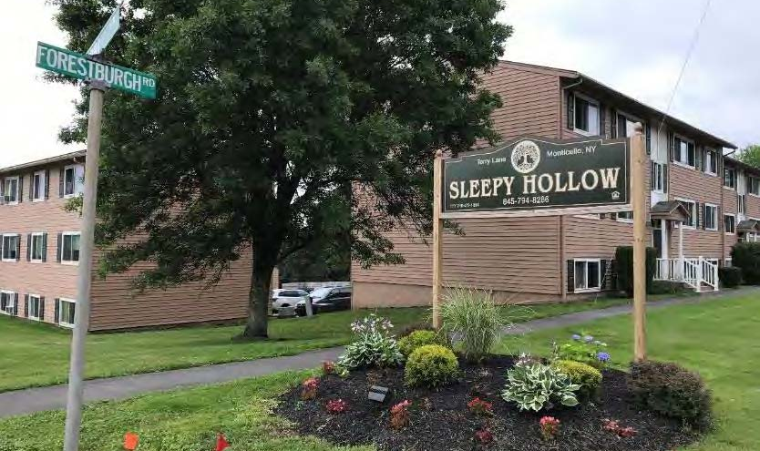
Sleepy Hollow Apartments will receive over $42,000 per unit in hard cost rehabilitation as part of Steele Properties’ acquisition. The scope of renovation encompasses both extensive exterior and interior work. Important building improvements include unit updates, new roofs, HVAC systems, and plumbing and electrical upgrades. Project amenities include a new community building, a new playground and outdoor pavilion, upgraded laundry facility as well as accessibility improvements in parking and common areas.

“Steele Properties is delighted to partner with New York Homes and Community Renewal, HUD, Citi Bank, and PNC Bank to successfully fund this significant rehabilitation project that helped us preserve and enhance 229 affordable housing units in New York. We are committed to ensuring everyone has access to safe, comfortable and quality housing they can afford, especially as our country faces an affordable housing crisis,” said Chad Asarch, Principal, Steele Properties.

This project is financed with Low Income Housing Tax Credits allocated by New York State Homes and Community Renewal (NYSHCR) and Tax Credit equity provided by PNC Bank. Tax Exempt Bond financing is provided by NYSHCR’s SONYMA Credit Enhancement program and Citi Bank is the construction lender. Subordinate financing is provided by NYSHCR’s Multifamily Preservation Program funded through the Multifamily Open Window RFP.

Built in 1970, Sleepy Hollow is a Project-Based Section 8 Family property consisting of 23 buildings and 229 units with a mix of one, two, three and four-bedroom apartment homes on 25.7 acres. Sleepy Hollow is located in the Catskills, at 39 Terry Lane, Monticello, New York.

About Steele Properties
Steele Properties is a Denver-based national real estate investment company specializing in the acquisition, rehabilitation and new construction of affordable family and senior rental properties. The company was formed in 2006 with the mission to preserve, improve and increase affordable housing opportunities for vulnerable communities across the country. Steele has successfully completed over $700 million in acquisitions, sales and development activity involving over 50 properties and more than 5,000 units, including over 40 tax credit projects.

About Monroe Group
Monroe Group is a privately held corporation headquartered in Denver CO. Stuart Heller founded the company over 30 years ago, with a single management contract for an 81-unit property. Today, the Monroe Group has grown to become one of the country’s leading affordable housing property management companies with a portfolio of 54 properties and over 5,000 units located in 16 states across the country. In 2006, Monroe Group’s leadership founded Steele Properties to conduct all real estate development and property acquisitions.

# # #

